Disable or Remove tabs from Relationship Grid
Author: Sean Coleman
Date: September 8th, 2008
Version: 1

Some implementations for Aras Innovator may necessitate that certain tabs in the relationship grid may require to only visible for certain groups. In the following sample provided in this document take into account the Part ItemType. The Part ItemType contains numerous relationships to other ItemTypes within Aras Innovator. When you open either an existing instance of a Part or create a new Part item the Part form is loaded. When the form is loaded the relationship grid is loaded as well, which contains tabs for each of the relationships to the Part ItemType.
As an Administrator you may require that some of these relationships are only viewable to certain groups within your system. The attached method attached to an “OnLoad” form event will help the user obtain these desired results. The code can easily be manipulated to take effect on the ItemType of your choosing allowing you to disable whichever tabs you deem necessary.
The following sample is used to remove the tabs for “Quality Planning Documents” and “Changes” on the form for the Part ItemType for all users except those that belong to the Quality Planning identity. You are also able to disable the forms so they are visible to the user, but unable to be clicked on. To achieve these results following these instructions:
- Log into Aras Innovator as an Admin
- From the TOC select Administration->Methods and create a new Client Side Java Script Method. Name it as you please.
- Insert the code from the end of the document (Note: The code currently removes the tab, the code to disable the tab is commented out)
- Save, Unlock, and Close the method.
- From the TOC select Administration->Form and edit the form of the ItemType you want to apply the method to (For the sample code written we use the Part Form)
- Select the “Form Event” tab and add a new Relationship.
- Select your newly created method and attach the “onLoad” event to it
- Save, Unlock, and Close the form.
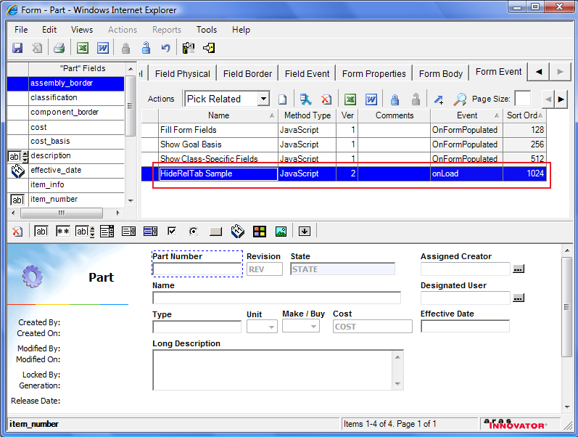
Attach Method for onLoad event to Part Form
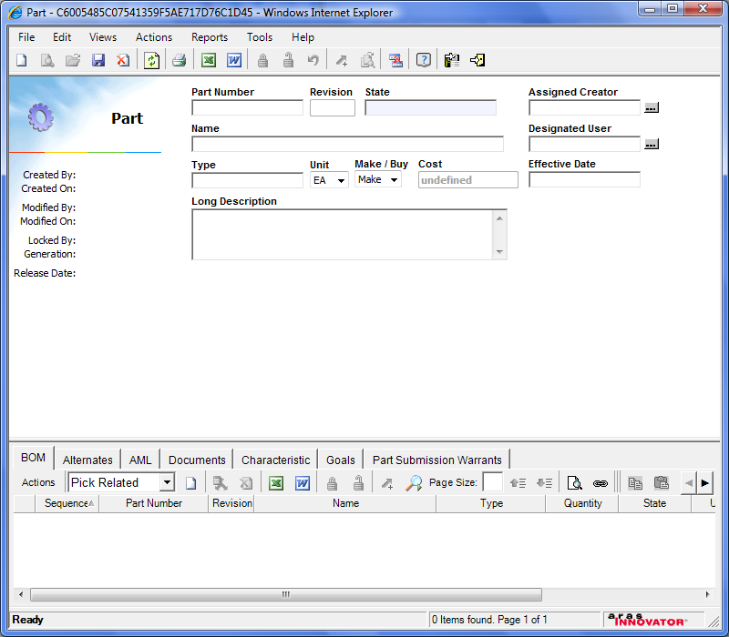
Not a Member of Quality Planning
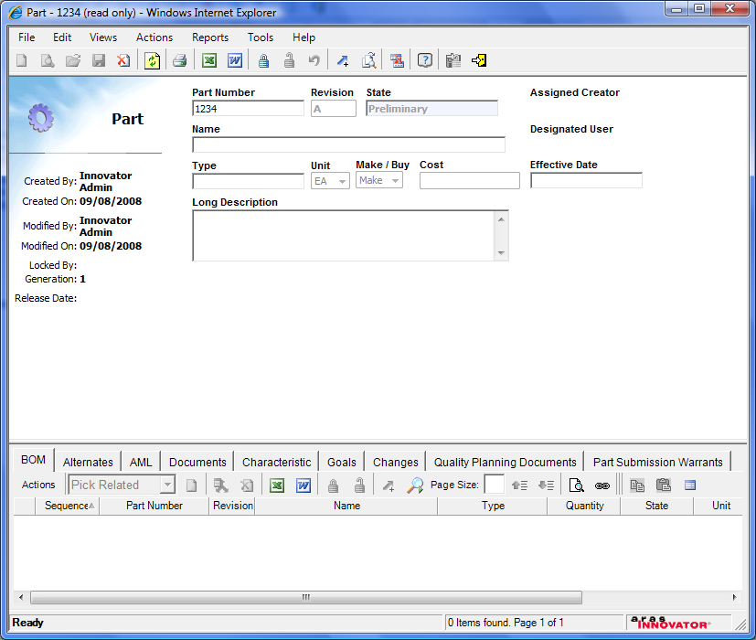
Member of Quality Planning

In the following method code there are three highlighted sections that will require you to customize for your own needs. The section highlighted in yellow is where you create the array of tab names you would like to have disabled.

The section highlighted in blue is where you will have to change the ID of the Identity you want to grant access to viewing all of the tabs. This can be done by executing a simple SQL query like: SELECT [id] FROM innovator.[identity] WHERE keyed_name = ‘Quality Planning’

The section highlighted in gray is an optional change. It is currently set up so it will remove the tab for users who do not belong to your selected identity. However if you would like to just disable that tab you can comment out the line that starts with removeTabByLabel and uncomment the line setTabEnabled. Doing so will leave the tab in a disabled state so it will not be able to be clicked on.

Method Code
// JScript source codefunction

function disableTabs()
{
//TEST FOR RELATIONSHIP FRAME
inn = document.thisItem.newInnovator();
if (!parent.relationships)
{
setTimeout(disableTabs, 100);
return;
}
//TEST TO VERIFY DOCUMENT IS READY
if (parent.relationships.document.readyState != "complete" || !parent.relationships.currTabID)
{
setTimeout(disableTabs, 100);
}
else
{
//ARRAY OF INVALID TABS FOR PART ITEMTYPE IF NOT IN QP IDENTITY
var part_tabs = new Array();
part_tabs[0] = 'Quality Planning Documents';
part_tabs[1] = 'Changes';

//TEST FOR USER PART OF QUALITY PLANNING IDENTITY

var userID = top.aras.getCurrentUserID();
var user = inn.getItemByID("User", userID);
var userName = user.getProperty("keyed_name","");
var QP_Ident = inn.newItem("Identity","get");
QP_Ident.setProperty("id","59C3B3567DA441529BB265886514C907"); //ID OF IDENTITY YOU WISH TO GRANT ACCESS TO
var memrel = QP_Ident.createRelationship("Member","get");
QP_Ident = QP_Ident.apply();
if (QP_Ident.isError())
{
return QP_Ident;
}

var isMember = MemberCheck(QP_Ident, userName,0);

//IF IS MEMEBER OF QUALITY PLANNING RETURN, ELSE DISABLE TABS
if (isMember == 1)
{
return;
}
else
{
//DISABLE OR REMOVE TABS
for (i=0; i<part_tabs.length; i++)
{
// REMOVES TABS FROM RELATIONSHIP GRID
parent.relationships.document.relTabbar.removeTabByLabel(part_tabs[i]);

// DISABLES TABS FROM RELATIONSHIP GRID
//parent.relationships.document.relTabbar.setTabEnabled(getTabId(part_tabs[i]), 0);
}
//ALERT FOR TO MANY LEVELS IN MEMBERSHIP STRUCTURE
if (isMember == -1)
{
alert('The membership structure for the "' + QP_Ident.getProperty("keyed_name","") + '" identity has exceeded 10 levels. Please contact your Aras Innovator Administrator to resolve.');
}

}
}
}
function MemberCheck(identity, userName, levels)
{
var isMember = 0;
var inn = document.thisItem.newInnovator();
var members = identity.getRelationships("Member");
if (!members.getItemCount() > 0)
{
return isMember;
}
else
{
for(var i = 0; i < members.getItemCount(); i++)
{
if (isMember == 1)
{
return isMember;
}
else if (isMember == -1)
{
return isMember;
}
var mem = members.getItemByIndex(i);
if (mem.getRelatedItem().getProperty("is_alias","") == '0')
{
var ident = inn.newItem("Identity","get");
ident.setProperty("id",mem.getRelatedItem().getProperty("id",""));
var memrel = ident.createRelationship("Member","get");
ident = ident.apply();
if (ident.isError())
{
return ident;
}
levels++;
if (levels > 9) //if membership > 10 levels possible circular reference breaks out of code
{
return -1;
}
isMember = MemberCheck(ident, userName, levels);
}
else
{
idenName = mem.getRelatedItem().getProperty("keyed_name","");
if (idenName == userName)
{
isMember = 1;
break;
}
else
{
continue;
}
}
}
}
return isMember;
}

setTimeout(disableTabs, 200); //delay to allow form to load

